Vedix

An Ayurvedic Website

Sanskruti Shimple  
*Department of Instrumentation*   
Vishwakarma Institute of Technology, Pune, India   
[sanskruti.shimple20@vit.edu](mailto:sanskruti.shimple20@vit.edu)

*Abstract*—  Today human beings are suffering from many challenges such as traits or diseases. Each year various diseases, viruses, and fungal infestation lead to fatalities. Ayurveda is a traditional system of medicine that comes from ancient India; it is based on the idea of balance within all bodily systems. The word Ayurveda comes from the Sanskrit words Ayur (life) and Veda (to know), making it the ‘science of life’.

Ayurveda employs diet, herbal treatment, and yogic breathing techniques to restore mental, physical, and spiritual health. Ayurveda is one of the few ancient systems of medicine that is still widely practiced in modern times. The Ayurveda, the traditional Indian medicinal system remains the most ancient yet living tradition with a sound philosophical and experimental basis. It is a science of life with a holistic approach to health and personalized medicine. It is known to be a complete medical system that comprised physical, psychological, philosophical, ethical, and spiritual health.[1]

The Ayurveda is the self-healing concept, the use of herbal treatment is equally important in this Indian traditional system of medicine.

Keywords— Ayurveda, Herbals, Medicines, Diseases, Life Sciences, Ayurvedic Medicines, HTML5, CSS3, JavaScript, Vs Code.

# Introduction

Ayurveda is considered by many scholars to be the oldest healing science. Ayurveda is a Sanskrit word meaning "science of life". Ayurvedic knowledge was born in India over 5,000 years ago and is often referred to as the "mother of all healing". It derives from ancient Vedic culture and has been taught to its students in oral traditions by skilled masters for thousands of years. Some of this knowledge was printed thousands of years ago, but much of it is inaccessible. Many of the principles of the natural healing system known in the West today have roots in Ayurveda, such as homeopathy and polarity therapy.

Ayurveda is the underlying tradition and way of life that helps each of us to assert and celebrate our ability to feel good. Ayurveda can help us: Synchronize with our true inner nature, Respect and develop our strengths, Sharpen the realm of our challenges, Face adversity And redirect harmful trends, and wait for the result. Instead, Ayurveda encourages you to actively participate in your healing journey.

This involves learning about the relationships between elements and the unique combinations that elements create, called doshas. This is explained below. First, let's take a look at the background of Ayurveda.

# Workflow:

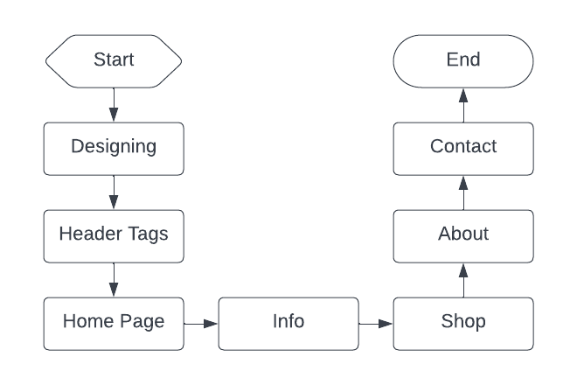

Algorithm: 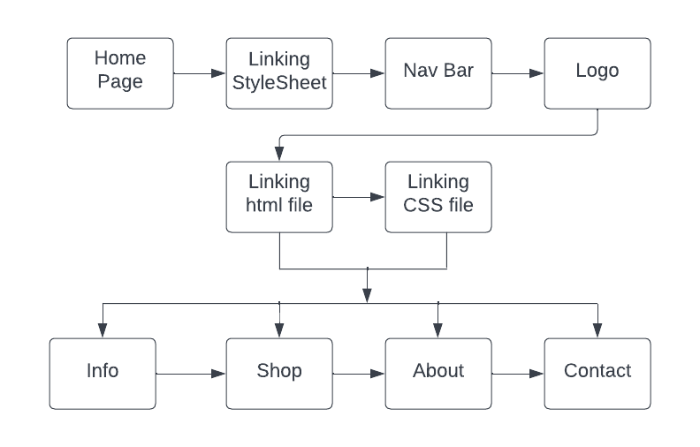

Tools Required:

* HTML3
* CSS5
* Canva
* Vs Code (Text Editors)
* Chrome

# LITERATURE REVIEW

Globalization is the process of interaction and integration among people, companies, and governments worldwide, causing growth in international trade and the exchange of ideas and culture. Ayurveda, the Science of Life, was in previous times, only available in the Indian subcontinent and surrounding countries. But with the advancement of time and technology, awareness of the great Science of Ayurveda has spread globally, and many nations now seek to explore this science. In 1978 the ‘Alma-Ata-Declaration’ by the WHO stated their evaluation and promotion of traditional medicine1. Which, after many policies and committees, eventually led to the birth and mainstreaming of the AYUSH Ministry in 2003. Today the globalization process of the Ayurveda system of medicine has reached many nations, due to the efforts of the AYUSH Ministry, especially in the Covid-19 pandemic situation the role of Ayurveda and AYUSH Ministry guidelines to boost immunity and the preventative aspect globally is something worth mentioning. In this article, an overview will be given as to what is being done globally, with a special focus on the status of Ayurveda in Trinidad and Tobago and Iran (Persia).[1]

It is common to hear a general statement that Ayurveda lacks scientific evidence. By scientific evidence, it is commonly referred to as the results of human clinical trials undertaken adoring those applied to pharmaceuticals, involving randomized controlled trials (RCT), either a placebo or active control. It explores the actual situation related to the practice of Ayurveda, the use of medicines, the application of therapies, and the individual dravyas (ingredients). It gives a few examples and the availability of a large body of scientific data in this area.[2]

Ayurveda is a science of life with a holistic approach to health and personalized medicine. It is one of the oldest medical systems, which comprises thousands of medical concepts and hypotheses. Interestingly, Ayurveda can treat many chronic diseases such as cancer, diabetes, arthritis, and asthma, which are untreatable in modern medicine. Unfortunately, due to a lack of scientific validation in various concepts, this precious gift from our ancestors is trailing. Hence, evidence-based research is highly needed for global recognition and acceptance of Ayurveda, which needs further advancements in the research methodology. The present review highlights various fields of research including literary, fundamental, drug, pharmaceutical, and clinical research in Ayurveda. The review further focuses to improve the research methodology for Ayurveda with the main emphasis on fundamental research. This attempt will certainly encourage young researchers to work on various areas of research for the development and promotion of Ayurveda.[3]

1. Clinical care: The practice of Integrative Medicine should be based on distinct definitions, should be informed by evidence, and evolve from guidelines that are developed by experts from conventional and complementary medicine.[4][1]

2. Education: Academic leaders and health officials have called for future clinicians to possess the knowledge and skills to understand how Integrative Medicine can be incorporated into conventional care to improve the health of the public. Therefore, it is essential to share best practices in how to create robust curricular opportunities for medical students to experience systematic teaching of the principles, strengths, and limitations of Integrative Medicine. [4][2]

3. Research: Within this Congress scientists will showcase the highest quality research worldwide in this field and will provide the state-of-the-science evidence base through plenary lectures, symposia, and abstract presentations. [4][3]

4. Traditional healing systems (THS): Traditional healing practices and practitioners are an important and often underestimated part of health care. THS is found in almost every country in the world and the demand for its services is increasing. Research contributing to evidence-informed decision-making is imperative to develop a cohesive and integrative approach to health care that allows governments, health care practitioners, and, most importantly, those who use health care services, to access THS in a safe, respectful, cost-efficient, and effective manner. [4][4]

5. Arts and medicine: For the first time at a research congress, this theme will explore the important contributions of the arts (music, visual arts, dancing, etc,) for integrative therapeutic interventions to achieve optimal health and healing. [4][5]

Ayurveda is an ancient science dealing with health care. In the ancient period, knowledge was passed down from mouth to ear in an oral tradition. Later on, the Acharyas began to record this knowledge by writing it down on different materials like palm leaves, birch bark, and copper plates. etc. Thus, Ayurveda began to be codified through centuries in written documents called Manuscripts. India is rich in its collection of medical as well as other manuscripts. Most of these remain unpublished. As such, several unique disease conditions and medical formulations contained in these texts are being lost by decaying. Many versions of the same text can be obtained from different places and therefore different readings about the same subject are seen. Ayurveda is mostly presented in the Sanskrit language, a slight difference in reading makes a lot of difference in the interpretation of its meaning critical tidal edition of a manuscript deals with the analysis of various versions of a text, to find out which is more meaningful and closer to the original text. It conveys many unique clarifies clarify the existing confusions and misinterpretations. Thus critical edition of all Ayurveda manuscripts is necessary. In the recent times, es a lot of Ayurveda scholars are coming up to bring out the knowledge hidden inside these manuscripts through their critical edition[5]

# IMPLEMENTATION

In this project, we will be using the concepts of web development. The various concepts of HTML3, CSS5, and JavaScript.

India emerges as the largest producer of Ayurveda. Ayurveda is an alternative medicine system with historical roots in the Indian subcontinent. The theory and practice of Ayurveda are pseudoscientific. The Indian Medical Association describes Ayurvedic practitioners who claim to practice medicine as quacks. Ayurveda is heavily practiced in India and Nepal, where around 80% of the population report using it. Ayurveda therapies have varied and evolved over more than two millennia.

Due to various foreign medical associations, the Ayurveda has been neglected to some extent. As it is a powerful source of self-healing for several diseases. Hence, we’re not taking most of the benefits of the Ayurveda. The solution to this is that building some of the resources which can promote Ayurveda. Hence creating a website can be one of the resources to promote the growth of Ayurveda.

The workflow of the vedix is such that, defining an appropriate name for the website, then comes the designing part of the website building the proper logo, posters for the background page, an appropriate theme for the website, and a combination of the colors. The actual building of the website starts with the coding part, the various concepts from html3, css5, and JavaScript are used for building this vedix website. Creating various pages such as the Home Page, Info Page, Shop Page, About Page, and the Contact Page.

# IV. Result

The development of an ayurvedic website that briefs the Ayurveda through various means.

Ayurveda or “sacred knowledge of longevity” has been practiced in India and many Asian countries since ancient times. Interest in Ayurveda began to grow around the world in the late 1970s after the Alma Ata Declaration was adopted by W.H.O. in 1978. Ayurveda in the New Millennium. The progress made in this field and formulate actions to take Ayurveda through the new millennium. It also identifies many of the obstacles that must be eliminated if Ayurveda is to meet the needs of a wider audience.

Features: New insights into the history of Ayurveda, Regulatory aspects regarding the production of ayurvedic medicines, Industrial production of traditional ayurvedic medicines, Quality control, The scientific reason for single herbal therapy, Biological effects of ayurvedic formulations, Optimization of ancient wisdom, and new knowledge, Herbal conservation is threatened, Nutraceuticals and cosmeceuticals from Ayurveda, A critical view of Ayurveda in the West, Directions to the Renaissance of Ayurveda

Ayurveda in the New Millennium: Emerging Roles and Future Challenges illustrates the power of Ayurveda and how to begin the renaissance of Ayurveda. The proponents of Ayurveda and all branches of traditional and alternative medicine. Experts from the fields of medicine, pharmacology, new drug discoveries, and food technology will also be useful.

Hence the “Vedix” website will help us to know the essentials of the Ayurveda. So, it will help the community to know the power of Ayurveda and its effectiveness in our day-to-day life.

As Ayurveda has the power to heal several diseases without any side effects. As Ayurveda is cost-effective and has several benefits.

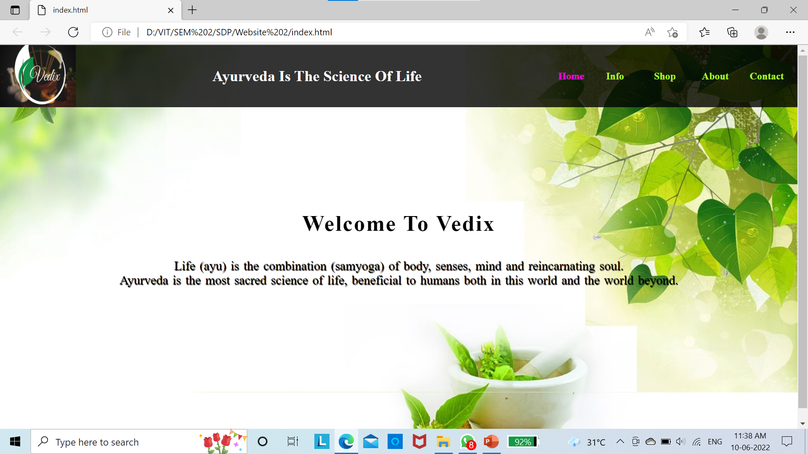

Home

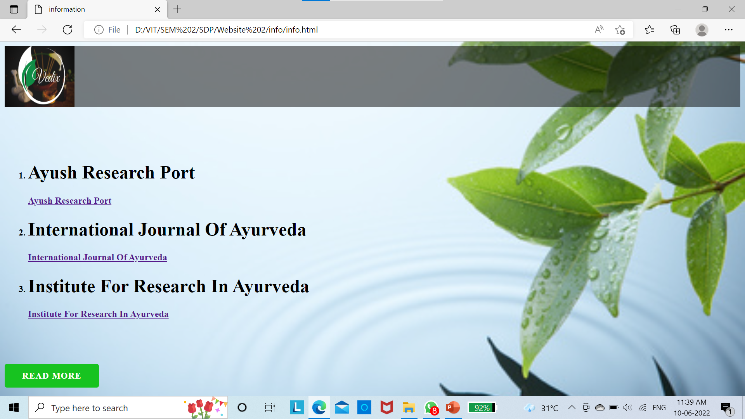

Info

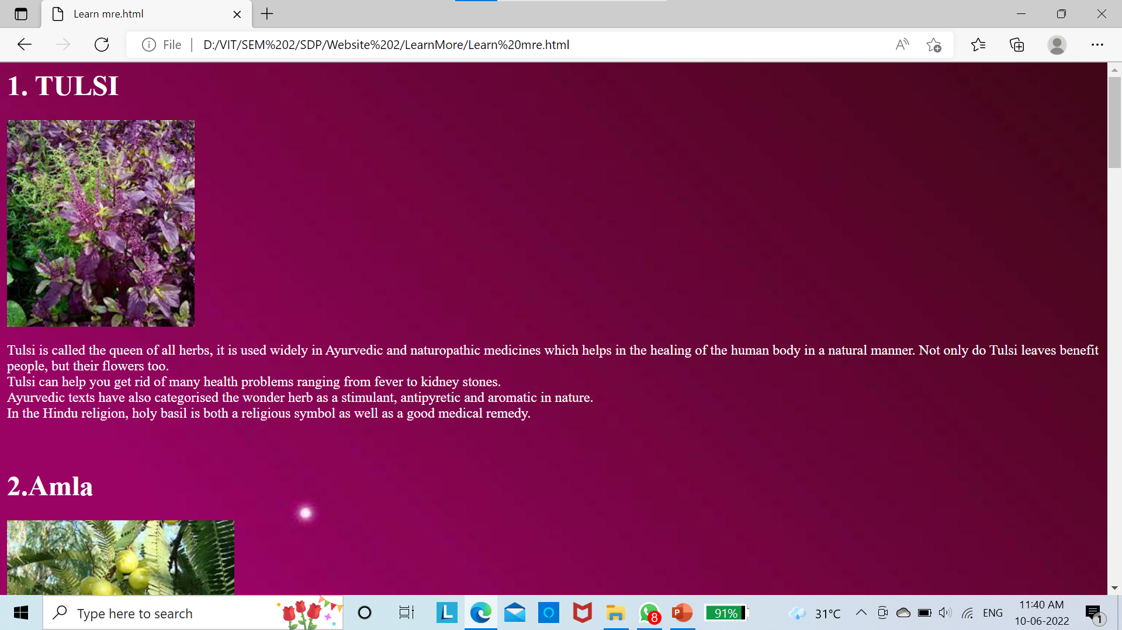

Read More



Shop

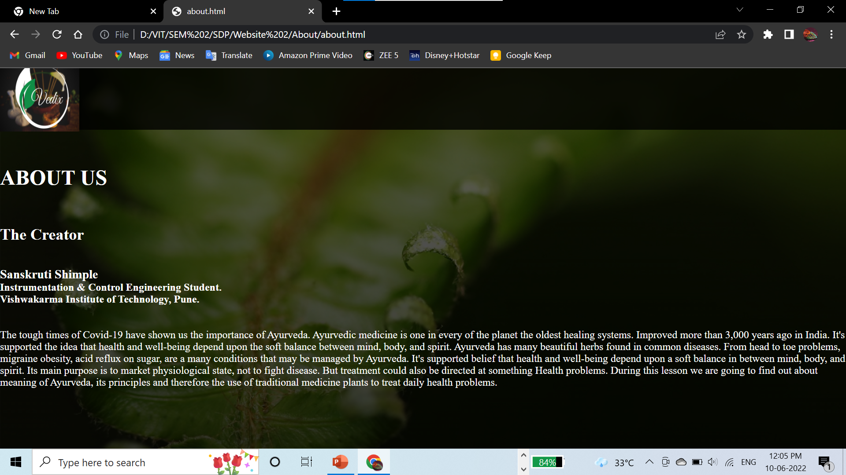

About



Contact

# V. CONCLUSION AND FUTURE DIRECTIONS

In this paper, the basic information from in-depth reading and present the latest complete review research work done on the awareness of Ayurveda.

An Ayurveda website is being created using various website development programming languages namely, HTML5, CSS3, and JavaScript. The website developed is namely, “Vedix” as it gives the complete information regarding the various Ayurvedic incentives.

This website gives the significance of Ayurveda. This tells users about Ayurveda and its benefits, advantages, features, and so on.

This website also tells the users about the essentials of Ayurveda in today’s modern era.

# References

1. Avvinish Narine1 , Fatemeh Moazzami Peiro2 , Gopesh Mangal3,

“GLOBALIZATION OF AYURVEDA" Article · December 2021

1. D.B. Anantha Narayana a, *, SharanbasappaDurgb,

Discussion Kernel “Ayurveda: (W)here is the evidence”

Journal of Ayurveda and Integrative Medicine 12 (2021)

1. Ashutosh Chauhan, Deepak Kumar Semwal1, Satyendra Prasad Mishra2, Ruchi Badoni Semwal3,

Departments of Biotechnology and 1 Phytochemistry, Faculty of Biomedical Sciences, 2 Vice Chancellor, Uttarakhand Ayurved University, Dehradun, Uttarakhand, India, 3 Department of Pharmaceutical Sciences, Tshwane University of Technology, Pretoria, South Africa.

“Review Article Ayurvedic research and methodology: Present status and future strategies”

1. Berlin, Germany. 3-5 May 2017

“World Congress Integrative Medicine & Health 2017: Part one”

Published: 30 June 2017,

BMC Complementary and Alternative Medicine 2017.

1. Anjana R S1*, Resmi B2 * 1Assistant Professor, Dept of Samhita, Samskrita and Sidhanta, VPSV Ayurveda College, Kottakkal, Malappuram, 2Professor, Dept of Samhita, Samskrita and Sidhanta, Govt Ayurveda College, Trivandrum.

“A REVIEW ON CRITICAL EDITION OF AYURVEDA MANUSCRIPTS’

International Journal of Ayurveda and Pharma Research